Computer Architecture Lab
(EL-2012)
LABORATORY REPORT

Fall 2026

(Lab#04)
Use of Venus Simulator for Register Level Execution of RISC-V Arithmetic and Memory Instructions

Student Name: Muhammad Hamza Roll No: 24i-6513 Section: B

Date performed: 09 , Sep , 2026

MARKS AWARDED: ________ / 10

Signature and date of Instructor: _________________
Lab Instructors: Dr. Nasir Ali Shah, Engr. Fasih Ahmad

______________________________________________________________________________________________________________________________________________________

NATIONAL UNIVERSITY OF COMPUTER AND EMERGING SCIENCES, ISLAMABAD
Prepared by: | Fasih Ahmad |  | Version: 1.0
Verified by: | Dr. Nasir Ali Shah |  | Updated: Fall 2026

Task 1:

Description:
// Write description of the task here 👇 (max. five to seven lines)
This program sets two variables A=5 and B=4, then computes C=A+B, D=A-B, AB, and AA, storing each result in separate registers (s3–s6). As with the others, it ends with an exit call, but a7 is never set to 10, so the exit doesn't actually execute correctly. No output is printed.
Code:
.data
.text
.globl main
main:
# I-Type immediate type
addi s0 , x0 , 5 # Variable A
addi s1 , x0 , 4 # Variable B

# R-Type Register type
add s3 , s0 , s1 # C = A+B
sub s4 , s0 , s1 # D = A-B
mul s5 , s0 ,s1
mul s6 ,s0 ,s0

# li is just -> addi a0 , x0 , 10 so it is I-Type
li a0 , 10
ecall
Output:
Step 0

Step 1
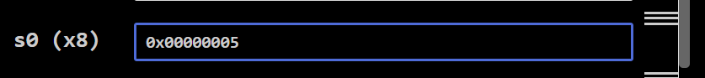
Step 3
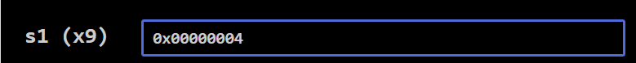
Step 4
Step 5
step 6
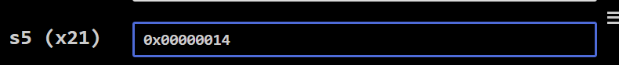
Step 7
Step 8
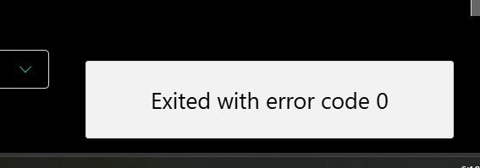

Task 2:

Description:
This program computes the expression (a-c) + (d+e)*f using values a=1, c=2, d=3, e=4, f=6. It calculates a-c and stores it in s0, d+e in s1, multiplies that by f into s2, then adds s0 and s2 to get the final result in s3. Like the others, it ends with an exit call, but a7 is never set to 10, so the exit doesn't execute correctly. No output is printed.
Code:

.data
.text

.globl main
main:

# using temporary registers
# let a= 1 , c = 2 , d = 3 , e = 4 , f = 6

# I-type because all do -> addi reg , s_reg , constant
li t0 , 1 # a
li t1 , 2 # c
li t2 , 3 # d
li t3 , 4 # e
li t4 , 6 # f

# using save register now

sub s0 , t0 , t1 # a-c stored s0 register

add s1 , t2 , t3 # d + e is stored in s1 register

mul s2 , s1 , t4 # (d+e) * f

add s3 , s0 , s2 # (a-c) + (d+e) * f

# li is just -> addi a0 , x0 , 10 so it is I-Type
li a0 , 10
ecall
Output:
// Import output here 👇
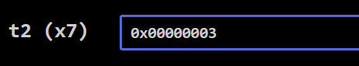
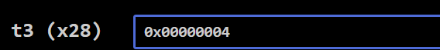
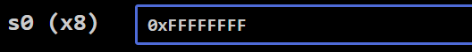
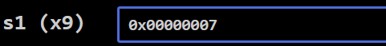

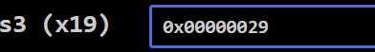
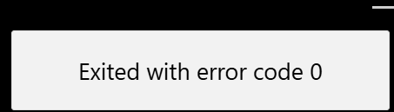

Task 3:

Description:
// Write description of the task here 👇 (max. five to seven lines)
this program loads two hex values into registers, then computes their bitwise AND, OR, and XOR, storing the results in s0, s1, and s2. It ends with an exit call, though a7 is never actually set to the syscall number, so the exit doesn't work correctly. No output is printed.
Code:
.data
.text

.globl main
main:

li t0 , 0xfff
li t1 , 0xf0f

and s0 , t0 , t1
or s1 ,t0 , t1
xor s2 , t0 , t1

# li is just -> addi a0 , x0 , 10 so it is I-Type
li a0 , 10
ecall

Output:
// Import output here 👇
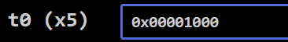
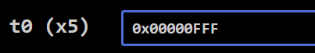
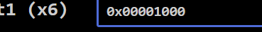
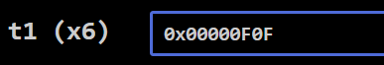
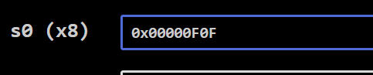
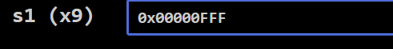

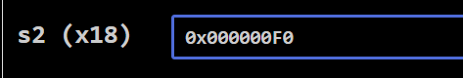
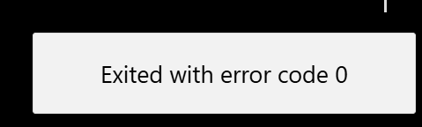

Task 4:

Description:
// Write description of the task here 👇 (max. five to seven lines)
This program sums the elements of a 6-element array (10, 20, 30, 40, 50, 60) using a loop in the arraysum function that adds each element to a running total, then returns the result in a0. However, main overwrites a0 with 10 right after the call and never sets a7, so the final ecall doesn't actually print anything or exit properly — the sum (210) is computed but never used.

Code:
.data
array: .word 10, 20, 30, 40, 50, 60

.text
.globl main

main:
la a0, array
li a1, 6

jal ra, arraysum
li a0, 10
ecall

arraysum:
li t0, 0
li t1, 0

loop:
bge t1, a1, done

slli t2, t1, 2
add t2, a0, t2
lw t2, 0(t2)

add t0, t0, t2
addi t1, t1, 1

j loop

done:
mv a0, t0
ret

Output:
// Import output here 👇
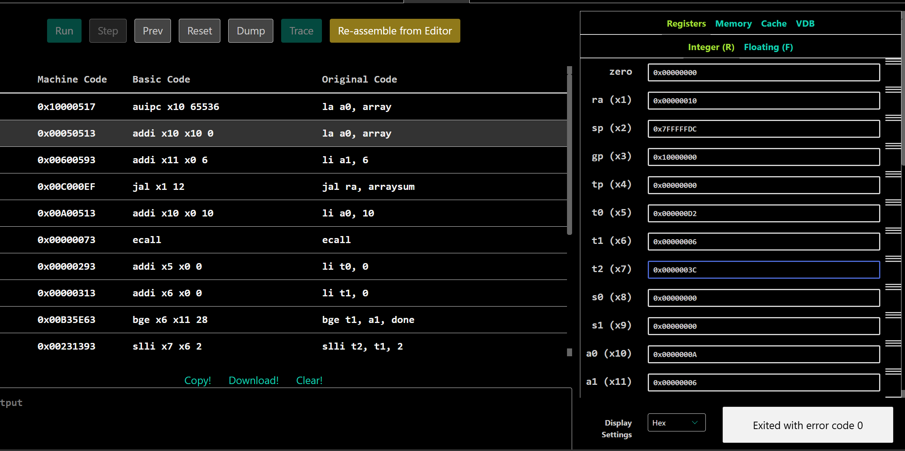

Task 5:

Description:
// Write description of the task here 👇 (max. five to seven lines)
This is a RISC-V assembly program that loads a table of 10 words (the multiples of 2 from 2 to 20) into memory, then loops through the array reading each value into register t3 (without doing anything with it), incrementing a pointer and counter each iteration, and exits once all 10 elements have been traversed.

Code:
.data

table_of_two: .word 2, 4, 6, 8, 10, 12, 14, 16, 18, 20

.text

.globl main
main:
la t0, table_of_two
li t1, 10 # Size
li t2, 0 # i for iterations

loop:
bge t2, t1, end # if t2 >= t1 jump to end

lw t3, 0(t0) # load word at address in t0 t3 is x28 register in which we load the words

addi t0, t0, 4 # move to next word (4 bytes)
addi t2, t2, 1
j loop

end:
li a0, 0
li a7, 10 # Venus syscall: exit
ecall

// Import output here 👇
